DSA 0601 - Data handling and visualization
Set 10 - Survey Responses Analysis

- Grouped Bar Chart for Question 1
Code:

library(ggplot2)

survey <- data.frame(
Survey_ID = c(1, 2, 3),
Question_1 = c("A", "B", "C"),
Question_2 = c("B", "A", "A"),
Question_3 = c("C", "D", "B")
)

q1_count <- as.data.frame(table(survey$Question_1))

colnames(q1_count) <- c("Answer", "Count")

ggplot(q1_count, aes(x = Answer, y = Count)) +
geom_bar(stat = "identity") +
geom_text(aes(label = Count), vjust = -0.5) +
labs(
title = "Distribution of Answers for Question 1",
x = "Answer",
y = "Number of Responses"
) +
theme_minimal()

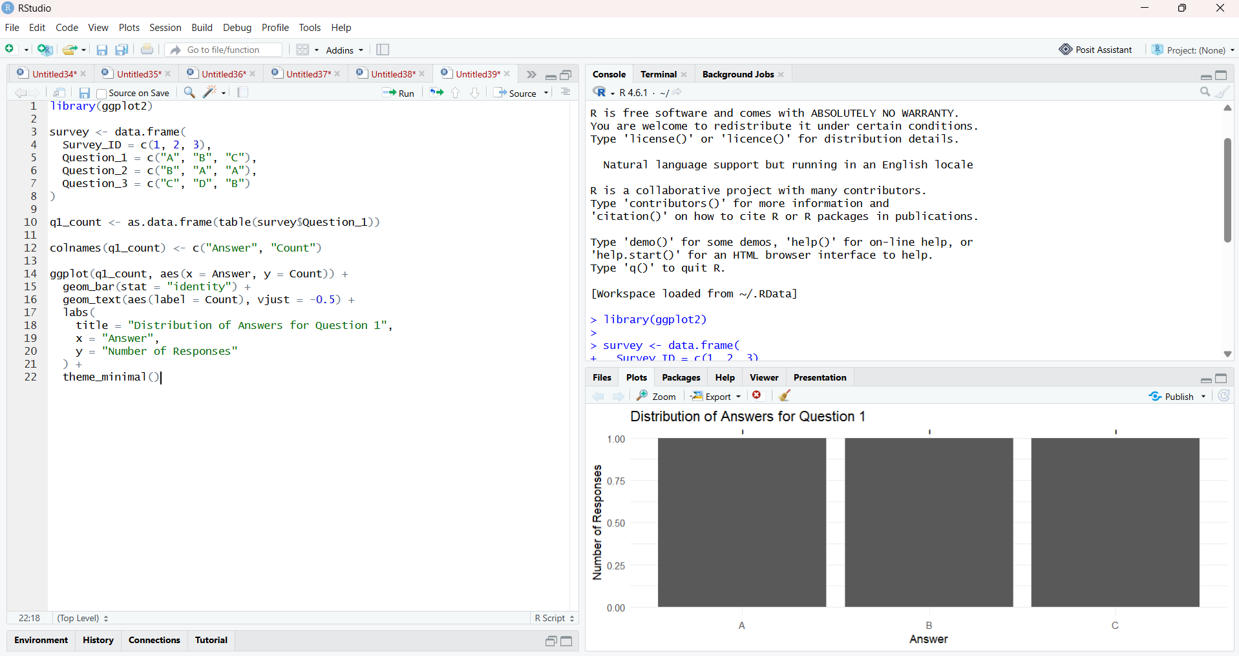

- Stacked Bar Chart for All Three Questions
Code:

library(ggplot2)
library(tidyr)

survey <- data.frame(
Survey_ID = c(1, 2, 3),
Question_1 = c("A", "B", "C"),
Question_2 = c("B", "A", "A"),
Question_3 = c("C", "D", "B")
)

survey_long <- pivot_longer(
survey,
cols = c(Question_1, Question_2, Question_3),
names_to = "Question",
values_to = "Answer"
)

ggplot(survey_long, aes(x = Question, fill = Answer)) +
geom_bar() +
labs(
title = "Overall Distribution of Survey Responses",
x = "Question",
y = "Number of Responses",
fill = "Answer"
) +
theme_minimal()

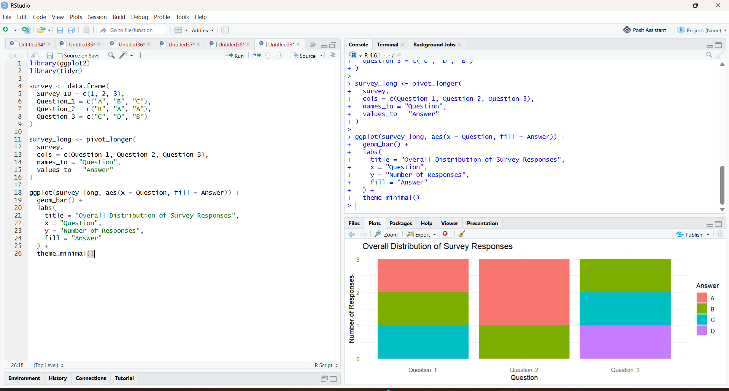

- Table of Survey Responses
Code:

survey <- data.frame(
Survey_ID = c(1, 2, 3),
Question_1 = c("A", "B", "C"),
Question_2 = c("B", "A", "A"),
Question_3 = c("C", "D", "B")
)

print(survey)

# Optional formatted table
library(knitr)

kable(
survey,
caption = "Survey Response Data",
col.names = c("Survey ID", "Question 1", "Question 2", "Question 3")
)

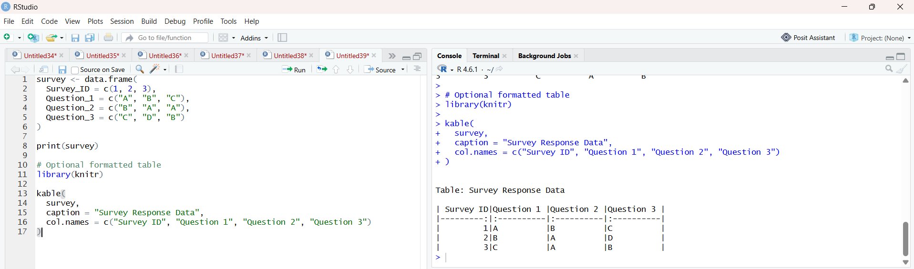

4. Prepare Data for Tableau Dashboard
Code:

survey <- data.frame(
Survey_ID = c(1, 2, 3),
Question_1 = c("A", "B", "C"),
Question_2 = c("B", "A", "A"),
Question_3 = c("C", "D", "B")
)

write.csv(
survey,
"survey_responses.csv",
row.names = FALSE
)

print("CSV file created successfully.")

